Kubernetes cluster /Nodes/Pods and servives

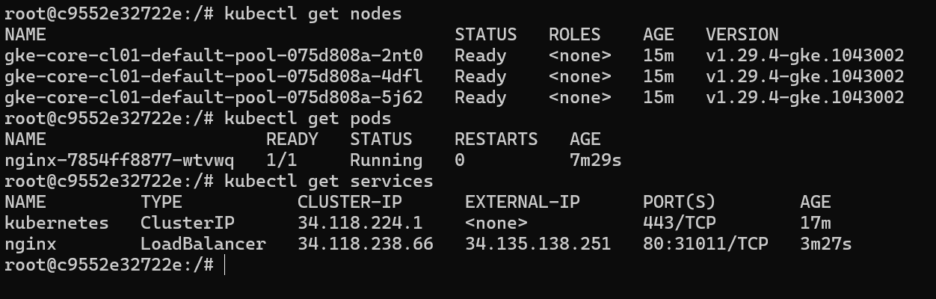

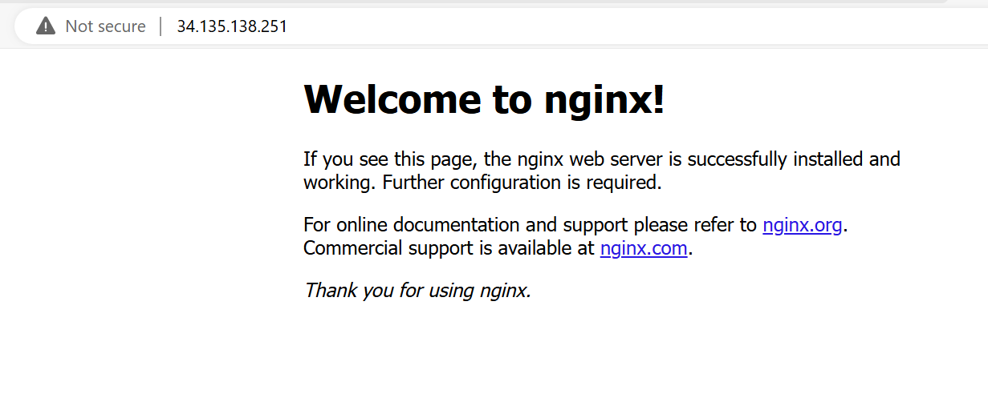

Cluster in GCP

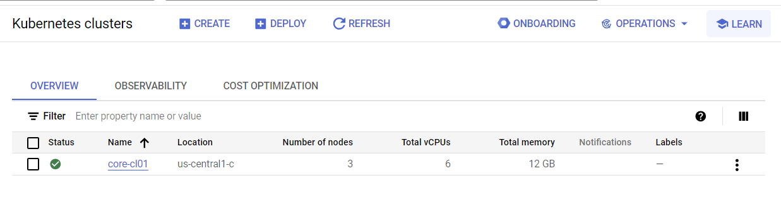

Cluster nodes as VM.

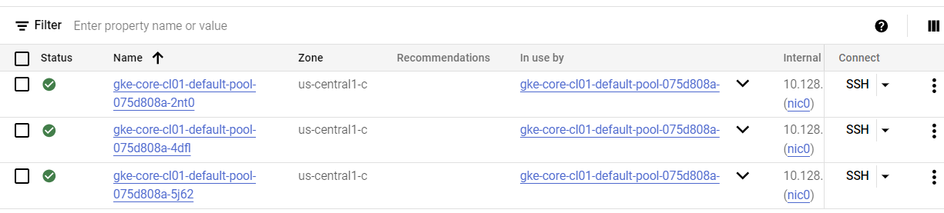

Docker desktop , Gcloud container running.

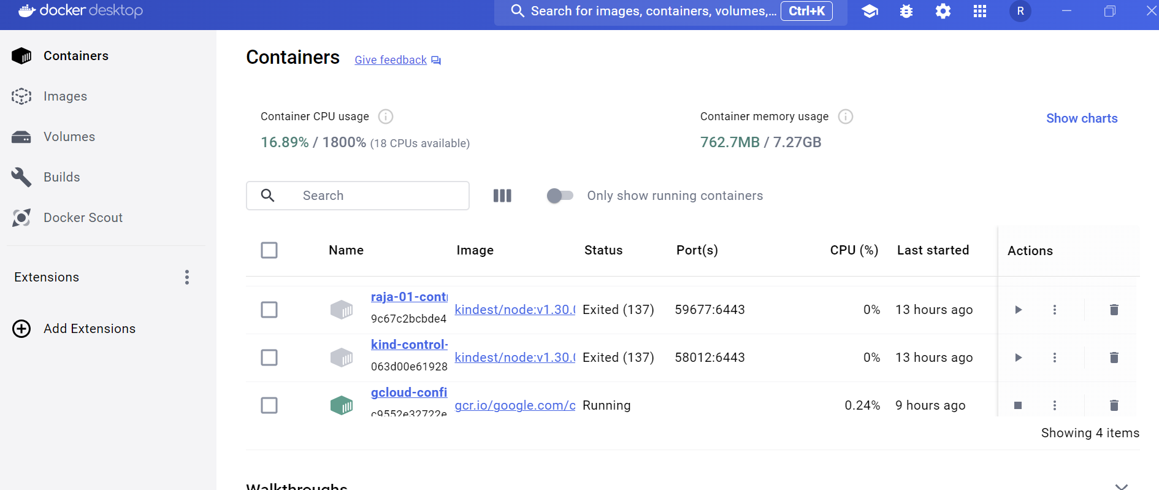

Powershell has been used to create all the above

